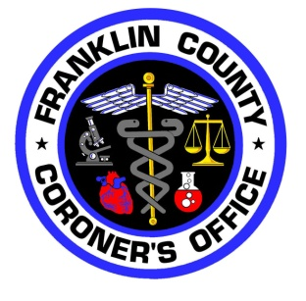

Contact: Dr. Anahi M. Ortiz

Franklin County Coroner

Phone: (614)525-5290

October 7, 2019

FOR IMMEDIATE RELEASE

**Press Release**

The Franklin County Coroner’s Office is releasing its preliminary overdose death statistics for the first six months of 2019.

From January 1 to June 30, 2019 the Franklin County Coroner’s Office saw 254 people die of overdoses. This is approximately an increase of 4% from the same period last year.

Opiate-related deaths accounted for 85% of overdose deaths for the first half of 2019. Fueling this was fentanyl which accounted for 75% of all overdose deaths.

Carfentanil-related overdose deaths accounted for 1.5%, similar to the same period in 2018. Heroin-related deaths accounted for 5% of all overdose deaths, a further decrease from the same period in 2018.

Cocaine, methamphetamine and benzodiazepine-related overdose deaths:

* Cocaine: 41%, an increase of 2% from 2018
* Methamphetamines: 10%, no change from 2018
* Benzodiazepines: 3%, a decrease of 3% from 2018



Contact: Dr. Anahi M. Ortiz

Franklin County Coroner

Phone: (614)525-5290

Looking at race and ethnicity, 28% of those who died of overdose deaths were African American, an increase of 7% from same period in 2018. The percentage of Hispanics who died of overdose deaths remained at 3% in 2019 as compared to 2018.

The number of males dying of overdoses continues to be higher than that of females. For the first half of 2019 we saw 69% of males dying and 31% of females. This is a slight shift of about 2% more females.

The top five zip codes with the highest number of overdose deaths for this period were: 43211, 43223, 43229, 43207 and 43204

All information will be on our website within the next few weeks.